

APTECH LEARNING PAKISTAN

Aptech Metro Star Gate Center(K(



**MEDI**

**Pharmaceutical Website**

# E-PROJECT

# 

|  |  |  |
| --- | --- | --- |
| Faculty | SIR Faizan Sabir | |
| Batch | **PR2 - 2023 – 09F1 MWF** | |
| Serial NO. | **Enrollment NO** | **Student Name** |
| 1 | Student1515970 | Danish Siddiqui |
| 2 | Student1517031 | Mr.Uzair |
| 3 | Student1517029 | Khuram Shazad |
| 4 | Student1516160 | Waqar Hussain |
| 5 | Student1506154 | Ali Tahir |
| 6 | Student | Syed Huzaifa |

**INDEX**

CERTIFICATE OF COMPLETION---------------------------------------------------------------------------(3)

ACKNOWLEDGEMENT---------------------------------------------------------------------------------------(4)

PROJECT SYNOPSIS------------------------------------------------------------------------------------------(5)

PROBLEM REQUIREMENT-----------------------------------------------------------------------------(5)

FUNCTION STATEMENT------------------------------------------------------------------------------------(6)

HARDWARE AND SOFTWARE REQUIREMENTS------------------------------------------------------(7)

WEBSITE FEATURES---------------------------------------------------------------------------------------(8)

USER GUIDE--------------------------------------------------------------------------------------------------(8)

HOMEPAGE (LANDING PAGE) ---------------------------------------------------------------------------(8)

ABOUT US--------------------------------------------------------------------------------------------------(9-10)

Products-----------------------------------------------------------------------------------(11-16)

Contact us--------------------------------------------------------------------------------------------(18-19)

Quote us----------------------------------------------------------------------------------------(20-25)

Careers----------------------------------------------------------------------------------------(26-27)

Navbar , Footer, Admin--------------------------------------------------------------------------------(28)

**CERTIFICATE OF COMPLETION**

This is to certify that **Danish Siddiqui , Mr.Uzair ,Ali Tahir,**

**Khuram Shazad , Waqar Hussain , Syed Huzaifa**have successfully completed their **HDSE**\*

Semester 3 E-Project.

Submitted to: **APTECH COMPUTER EDUCATION**

**ON**

**Feb, 22,2025**

**ACKNOWLEDGEMENT**



**First of all, we would like to thank Almighty Allah for giving us strength and**

**ability to complete this project.**

**And then, we would like to express my special thanks of gratitude to our teacher Sir Faizan Sabir who guided us on the**

**Project *Medi Pharmaceutical * Website* which also helped us in doing a lot of new learning and we come to know about so many new things we are really thankful to him.**

**We are highly thankful to Sir Faizan Sabir for his guidance and constant supervision as well as for his support in completing the project.**

**Lastly, we would also like to thank our parents and friends who helped us a lot in finalizing this project within the limited time frame. We also express**

**our sincere gratitude to E-Project team from Aptech Head Office, for their valuable guidance and support for the completion of this project. We earnestly hope this project will provide all the necessary information**

**required by the user to full fill his/her inspiration. However, suggestion and Feedbacks for improvements will be thankfully welcomed &acknowledge.**



The pharmaceuticals sector is a highly R&D intensive industry. The Medi is an Pharmaceuticals company which deals with products like Capsule/Encapsulation, Tablet, Liquid Filling, Blending, Process Equipment, Used Equipment. This organization now wants the entire process to be explained in as a web application so as to enhance the advertisement of the company and to increase its profit. For this the company has approached to make the website and also provided the list of the functionalities expected.



The Company has approached you to make the website and also provided the list of all the links and functionalities provided. They also want to provide a link of making a career where the interested candidates can login and provide their information (like their personal and education, professional details and also they will have the link to upload their resume).

There would be link for User Quote where user can provide their valuable feedback or any requirement.

It also wants to explain the list of the process being carried along with the details and dimension. The Process like Capsule/Encapsulation, Tablet and Liquid Filling must be explained.



The Web site is to be created based on the following requirements.

The Page should have the following links and menus

* ***Home Page:*** It should have the introduction description about the company. All the links must be stated in this page. The link like Home, About us, Products, Contact us, Careers, Quote, Admin Login.
* ***About us:*** it should flash the details of the Company (organization)
* ***Products:*** Here the list of the Products which are developed must be stated. Products like:
  + **Capsule/ Encapsulation**: The details of the products must be entered like
    - * Output
      * Capsule size ( in mm)
      * Machine dimension
      * shipping weight ( in kg)
    - Examples of the list of the products are mentioned below:
      * Profill 100 (2000 c/hr): it produces 2000 capsule per hour.
      * Profill 3007 (9000 c/hr): it produces 9000 capsules per hour.
      * Model 8S (18000 c/hr): it produces 18000 capsules per hour. Note you can take any other products also.
  + **Tablet:** Here the details of the Tablet process must be there. It will store the details like
    - * Model number
      * Dies ( like 1 set, 2 set and so on)
      * Max Pressure
      * Max Diameter of tablet (in mm)
      * Max depth of fill (in mm)
      * Production capacity
      * Machine size
      * Net Weight (in kg)
    - Examples of the tablet are mentioned below
      * TDP
      * VSP
      * CP 501 (Note you can take any other product also)
  + **Liquid Filling:** Here the details of the Liquid filling must be explained. It will store the details like :
    - * Air pressure
      * Air Volume
      * Filling Speed ( Bottles/min)
      * Filling Range ( in ml)
    - Examples of the Liquid filling is DHF( Double Headed Filter)
* ***Contact Us*:** Here the contact details must be flashed.
* ***Quote us:*** Here the suggestion or effective feedback can be provided. The details like :
  + Full Name
  + Company Name
  + Address
  + City
  + State
  + Postal Code
  + Country
  + Email Address
  + Phone
  + Comments
* ***Career:*** It will provide the candidate opportunity to apply for the job by creating their account. There will be two section one for Candidate Login and other creating the account.
  + Candidate Login : It will open the particular candidate account by using authentication( with their existing email Id and password they select). Once the account is opened the candidate will get three tabs to be modify:
    - * Resume (for uploading the resume)
      * Personal details
      * Education details
  + Creating Account: Here the candidate account will be created by filling all the above mentioned details along with the password (authentication purpose).
* ***Admin login:*** it will have to main task
  + The details of the site can be updated. Admin can also view the details of the job seeker candidate.
  + If the candidate profile is found to be interest then their will be option of Email in the same page. Once the admin click on the email option then a composing mail window must be opened with option like TO, Subject, Text and Send button. In the text the admin will call the selected candidate for the interview.



**Hardware**

* A minimum computer system that will help you access all the tools in the courses is a Pentium 166 or better
* 64 Megabytes of RAM or better

**Software *[Either or Combination as per Course/Sem]***

* Notepad/HTML editor/CoffeeCup
* Angular / Angular JS / React / BootStrap
* Dreamweaver / Figma / visual studio
* MS IE / Chrome / FireFox / Netscape /MS Edge

**USER’S GUIDE**



Prototype (Screen Shot of the Project Interface)

**Login:**

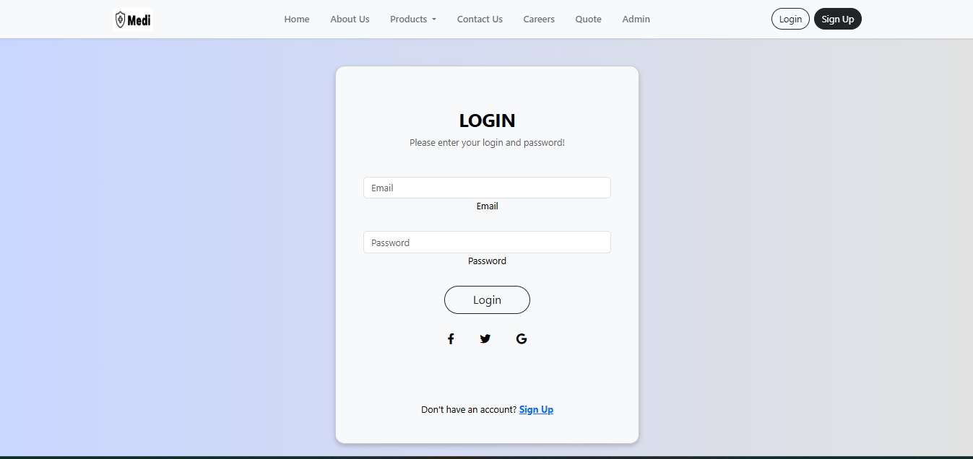

**Signup:**

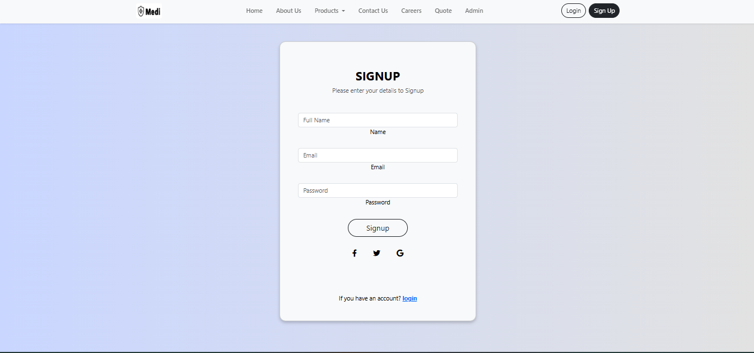

**Home Page:**

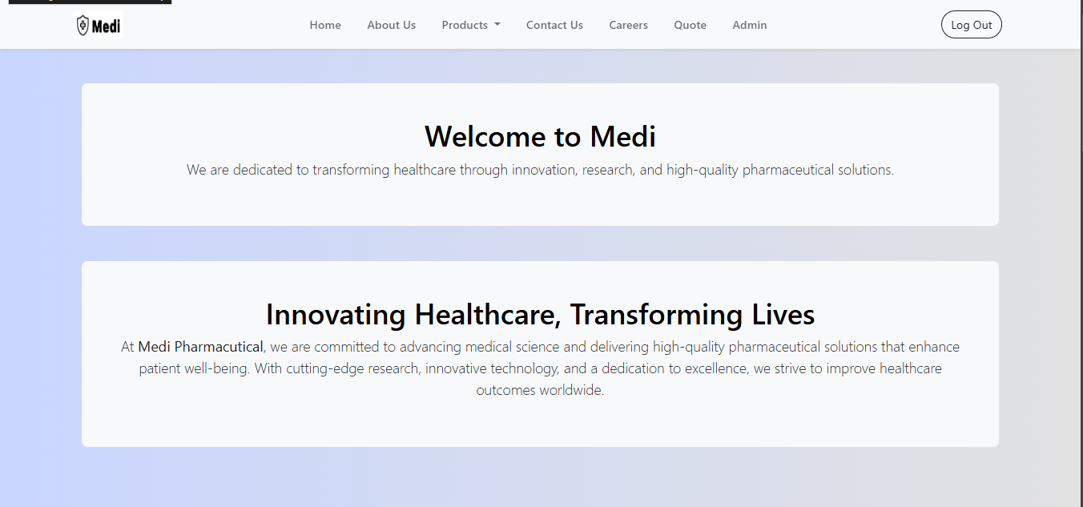

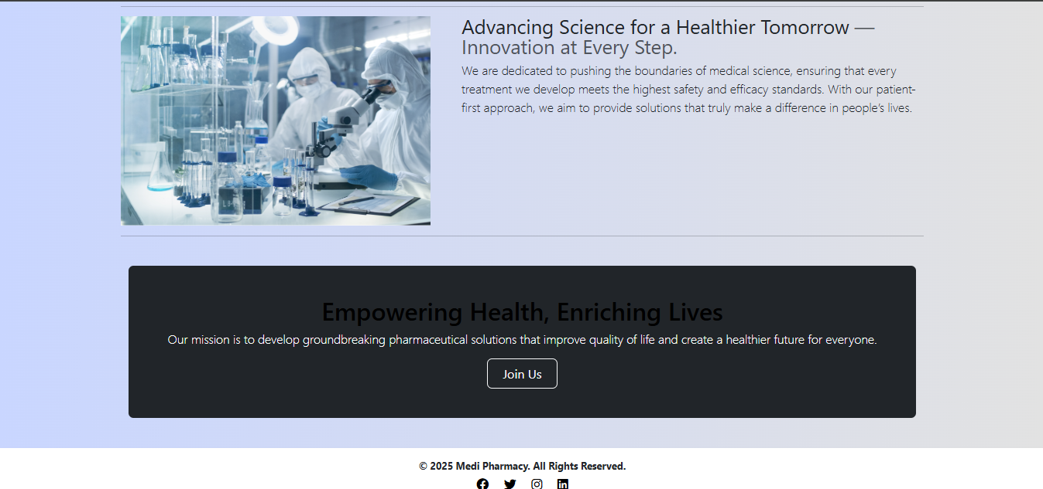

**About Us**

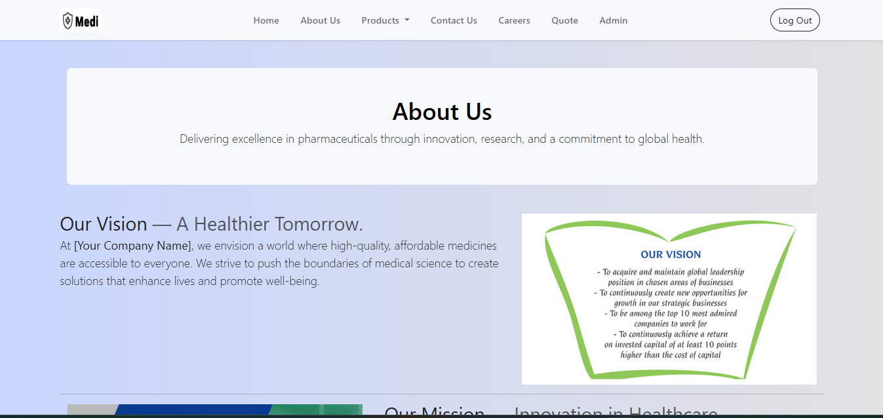

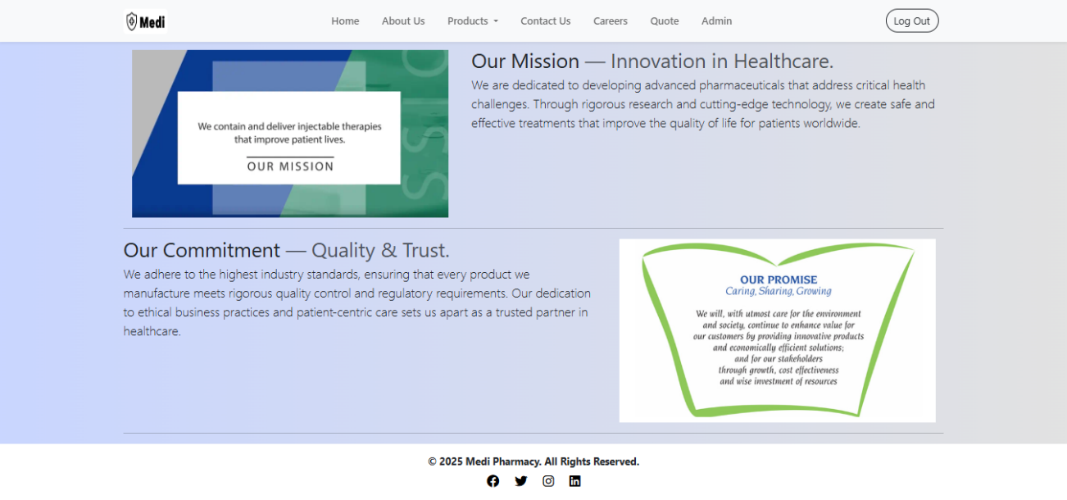

**Liquid Products**

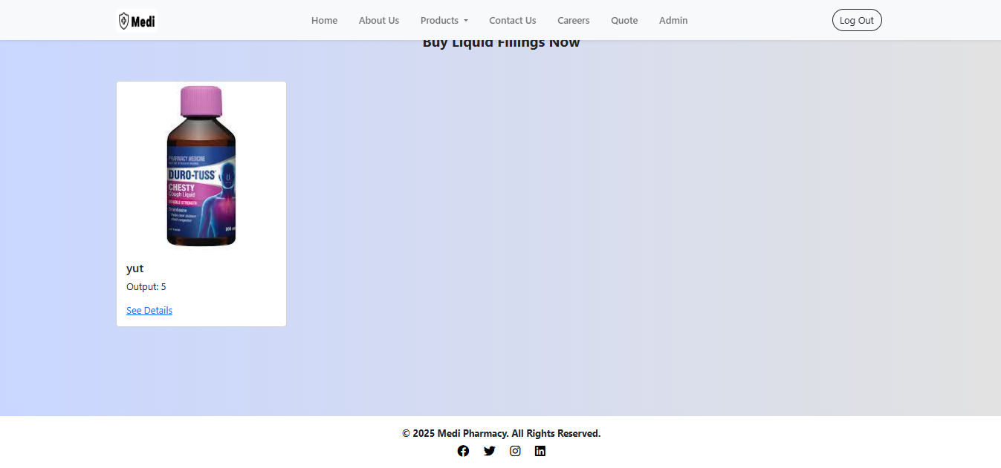

**Tablets Product**

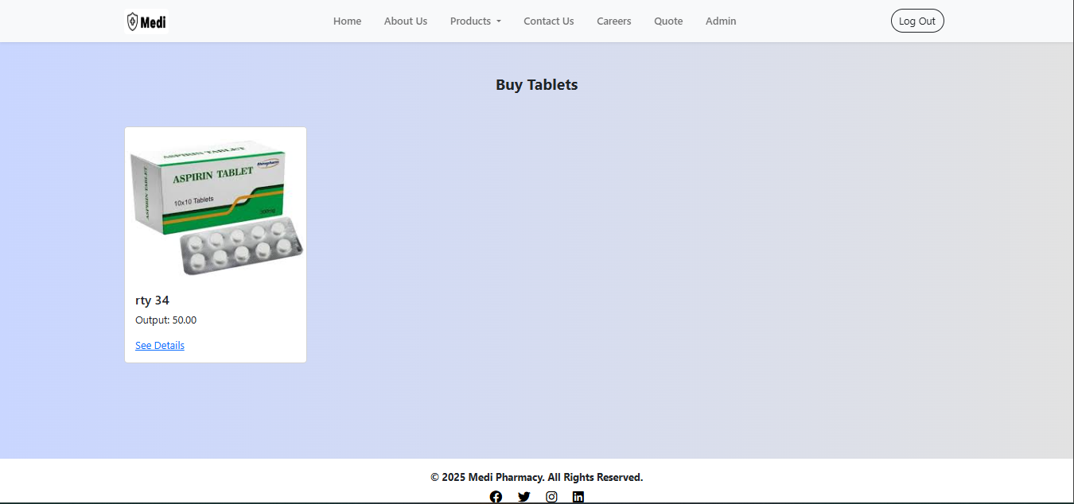

**Capsul Product**

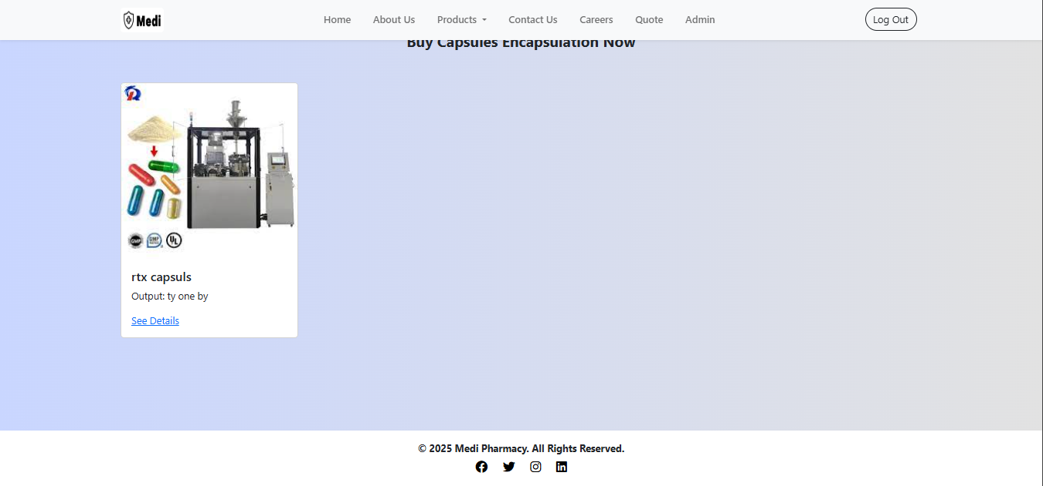

**Contact us**

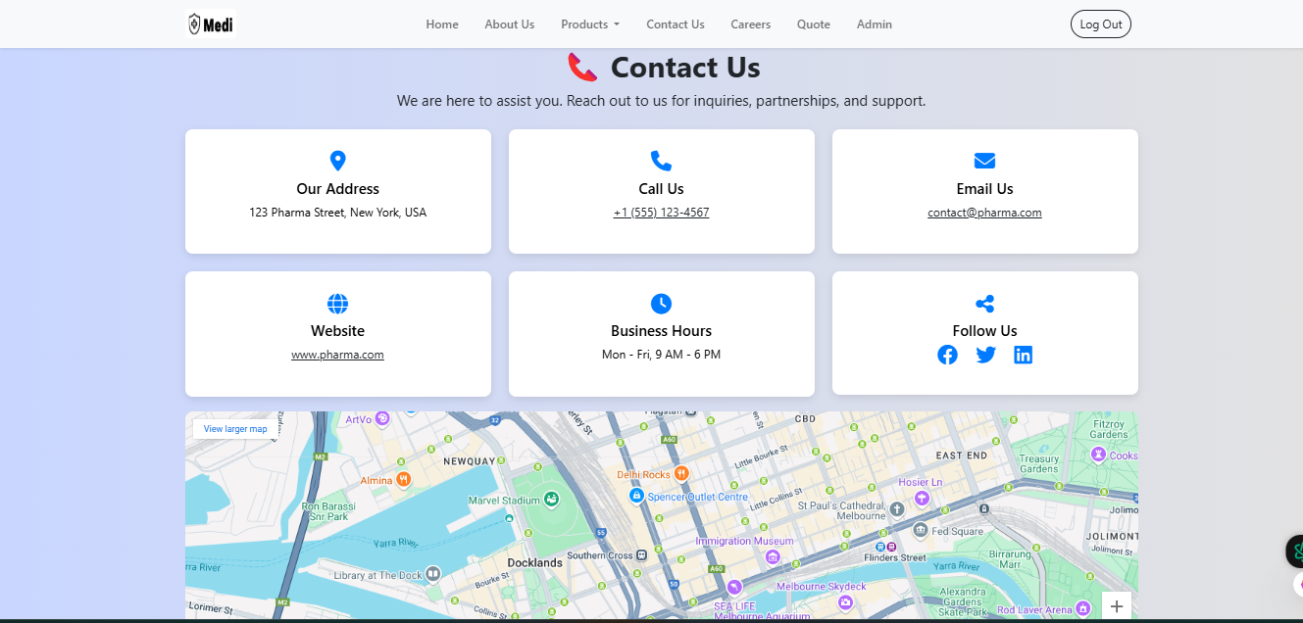

**Careers**

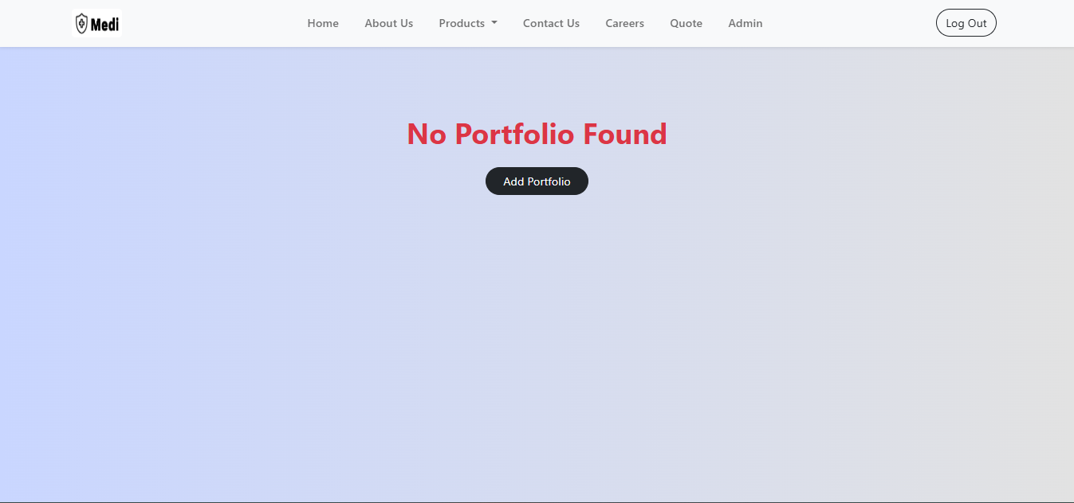

**Quote us**

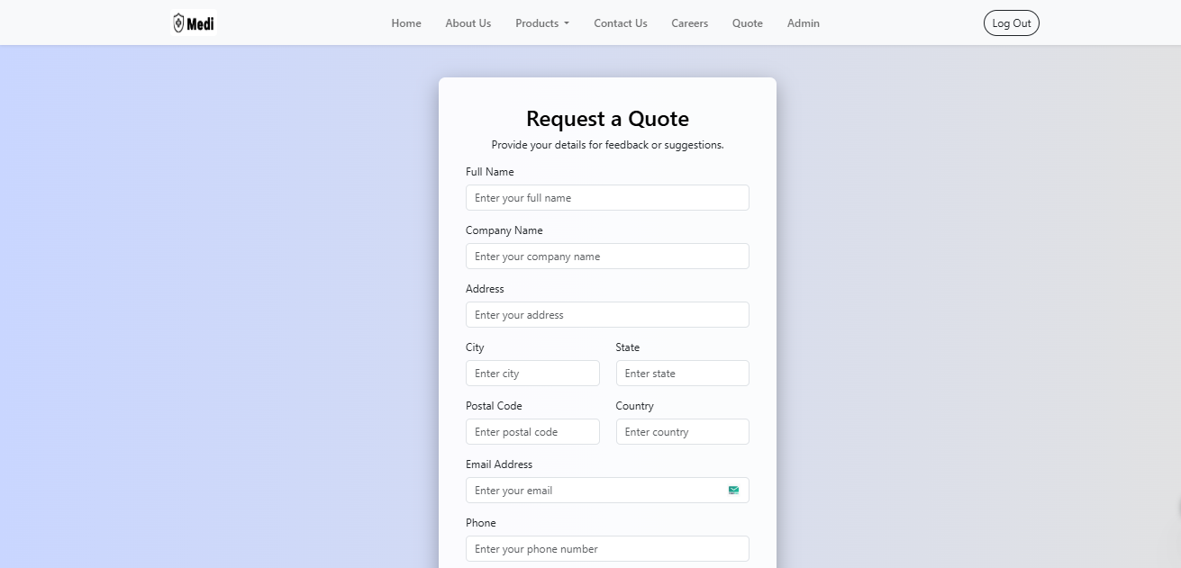

**Add Portfolio:**

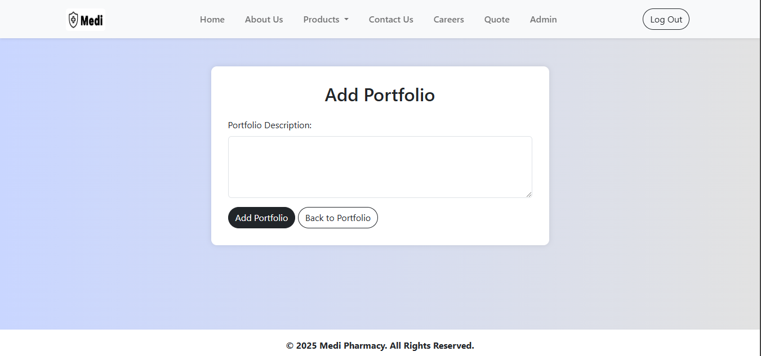

**Navbar:**



**Footer:**



**Admin Dashboard:**

